**Guideline**

 Bookmark this page

There are three compulsory submissions and two optional submissions.

Three Compulsory Submissions:

1. Group Mid Presentation

2. Group Final Report

3. Individual Submission 3: Access (Shell)

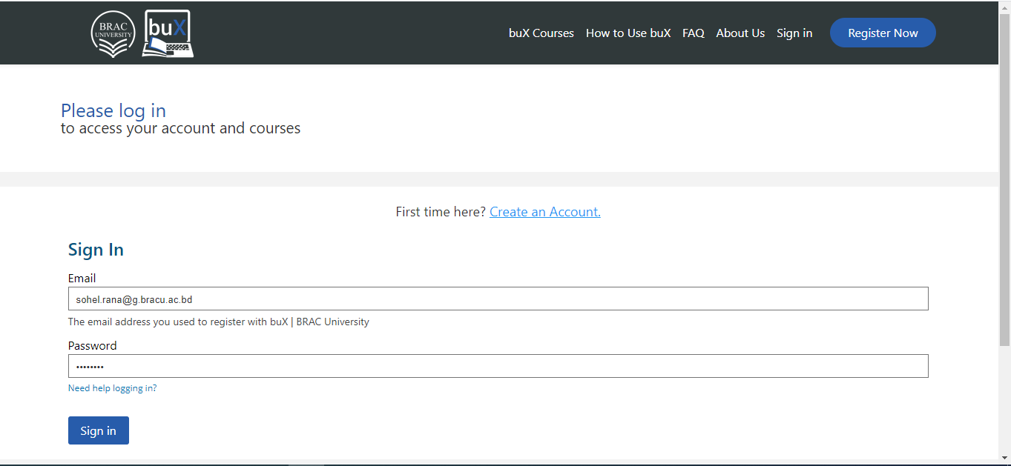

Two Optional Submissions

4. Optional Individual Submission 4: Job Handling (GNU Parallels / SLURM / OpenMP etc.)  
5. Optional Individual Submission 5: Extra-Credit/Bonus

Opportunities:

There are multiple opportunities for submissions. Depending on dates we can earn:

25% bonus

Regular mark

No mark (becomes a self-practice work only)

Submission link:

<https://forms.gle/Lo2YFWTN7doUfmLSA>

Submitter:

For group submissions, this form must be submitted by only ONE of the group members with correct name and ID of everyone in the group.

For individual submissions, please submit your ones.

Format:

All submissions except the group final report are video submission.

For video submissions, submit link to your video after uploading to GitHub/GitLab/unlisted youtube video.

For group final report, please see the details below.

Topic Selection:

Topic for Group Presentation and book chosen for Group Report should be unique for each group. Please select from <https://docs.google.com/spreadsheets/d/1sPVrb_R41mTPEkj-RCRoHhc54EajujWJCyujdAXyBEU/edit>

Details of the submissions:

============================================================================================

1. Group Mid Presentation:

============================================================================================ Prepare a presentation slide (5 to 8 slides) at <http://docs.google.com/presentation/> Submit screen+audio recording (appx 15 minutes) of your presentation via unlisted youtube link or uploaded file at github/gitlab. Guideline for reading a paper and presentation: <https://people.cs.aau.dk/~hans/Dat5/slides.pdf> 1st submission, 25% bonus: On or before Thursday, December 24 1st submission, regular mark: On or before Monday, December 28 1st submission, No mark (becomes a self-practice): On Tuesday, December 29 or afterwards

============================================================================================

2. Group Final Report

============================================================================================

Choose any one (or more) of the chapters from any listed unique books and prepare one-page short summary in the form of a “concept map”. Recommended Reading: <https://learningcenter.unc.edu/tips-and-tools/using-concept-maps/> Submission format: Include your digitally editable concept-map uploaded to github/gitlab or publicly viewable online link created at online sites like <https://www.lucidchart.com/pages/concept-map> 2nd submission, 25% bonus: On or before Monday, January 4 2nd submission, Regular mark: On or before Friday, January 8 2nd submission, No mark (becomes a self-practice): On Saturday, January 9 or afterwards

============================================================================================

3. Individual Submission: Access (Shell)

============================================================================================

please create a 10mins to 15 mins (appx) video showing a summary of how to use a shell based on <https://hpc-carpentry.github.io/hpc-shell/> Dates: 3rd submission, 25% bonus: On or before Thursday, December 24 3rd submission, Regular mark: On or before Thursday, December 31 3rd submission, No mark (becomes a self-practice): On Friday, January 1 or afterwards

============================================================================================

4. Optional Individual Submission: Job Handling (GNU Parallels / SLURM / OpenMP etc.)

============================================================================================

Based on <https://deapsecure.gitlab.io/deapsecure-lesson01-hpc/> or <https://hpc-carpentry.github.io/hpc-intro/> or OpenMP Create a 5 minutes tutorial on basics of GNU Parallels / SLURM / OpenMP usage. Dates: 4th submission, Regular mark: On or before Friday, January 1 4th submission, No mark (becomes a self-practice): On Saturday, January 2 or afterwards

============================================================================================

5. Optional Individual Submission: Extra-Credit/Bonus

============================================================================================

List all additional study materials that you have studied, courses completed, certificates earned, etc. along with proof and a short summary of each.